# Student Assessment Survey Analysis

# Level 1 Assessment:

* Two schools were involved in the assessment, that is, Kongoni primary school (95 pupils) and St. Joseph primary school (52 pupils).
* A total of 147 pupils participated in the assessment, 69 males and 78 females from the two schools as shown in the table below.

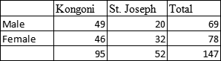

**General Performance Across all Subjects**

* The students generally performed higher in numeracy (Mean=54.9%) followed by the world around us (Mean=49.7%) with literacy(M=35.6%) coming last. Though there is a higher variation in the performance in literacy with values ranging from 0%-100%.
* When grouped by school Kongoni has a higher mean in numeracy than St.Joseph while St.Joseph has a higher mean in world around us than Kongoni
* When grouped by gender the trend is still the same, numeracy still having a higher performance mean but the females are leading than the males , the males are doing better in literacy than the females. The females are performing better in the world around us than the males.
* Though females are performing better in numeracy and the world around us while males are performing better in literacy, the differences in performance is very minimal.
* Kongoni is performing slightly better than St. Josephs with an average mean of 48.1% compared to St. Josephs mean of 46.6%.
* The performance of St. Josephs students is almost the same across all the three assessment areas. While that of Kongoni greatly varies with Science being the schools’ poorly performed assessment area.

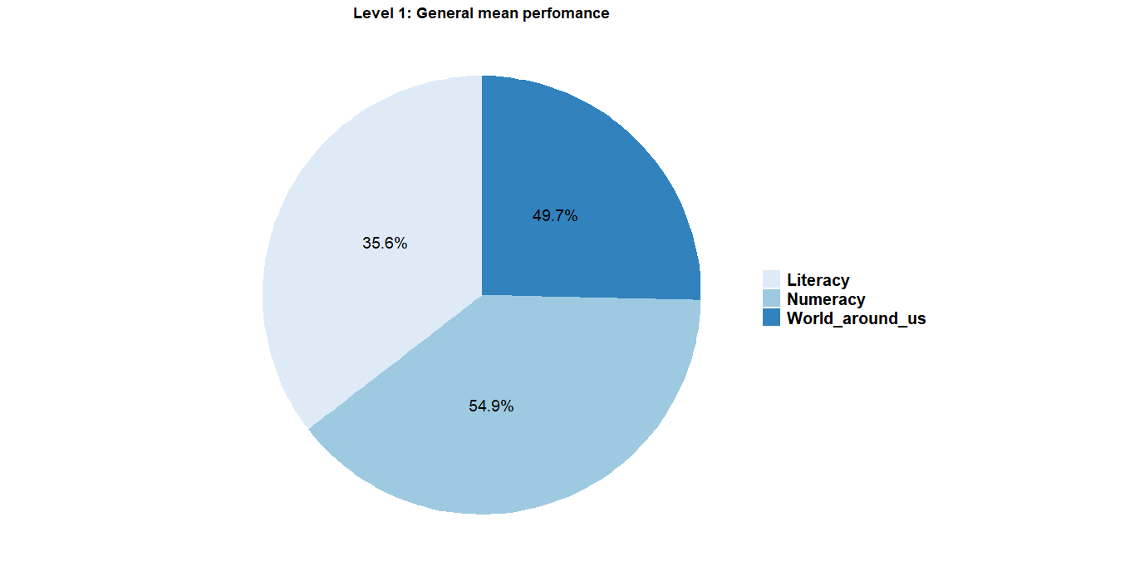

*Pie Chart representing the general performance of the three assessment areas for Level 1*

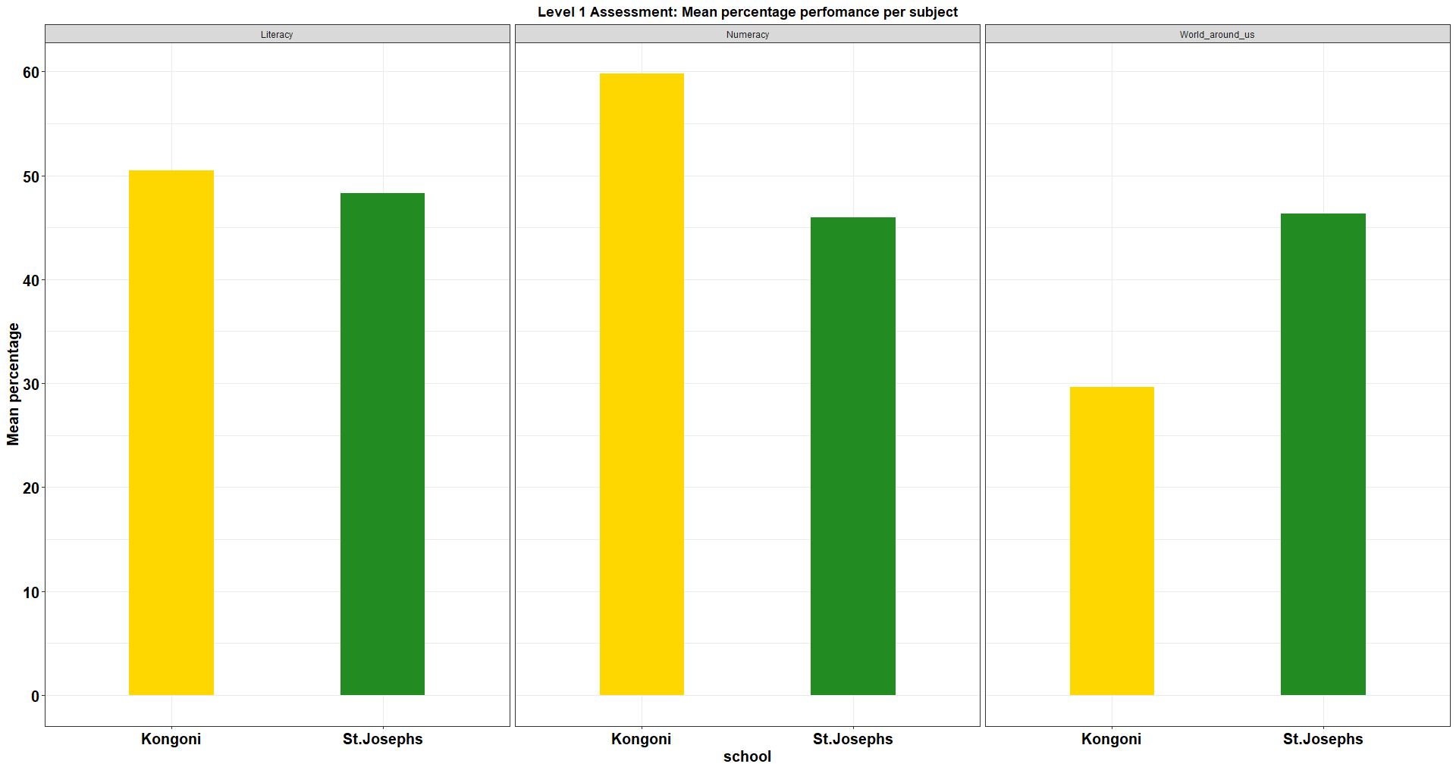

*Bar graph* *representing the general performance of the three assessment areas for Level 1 by school*

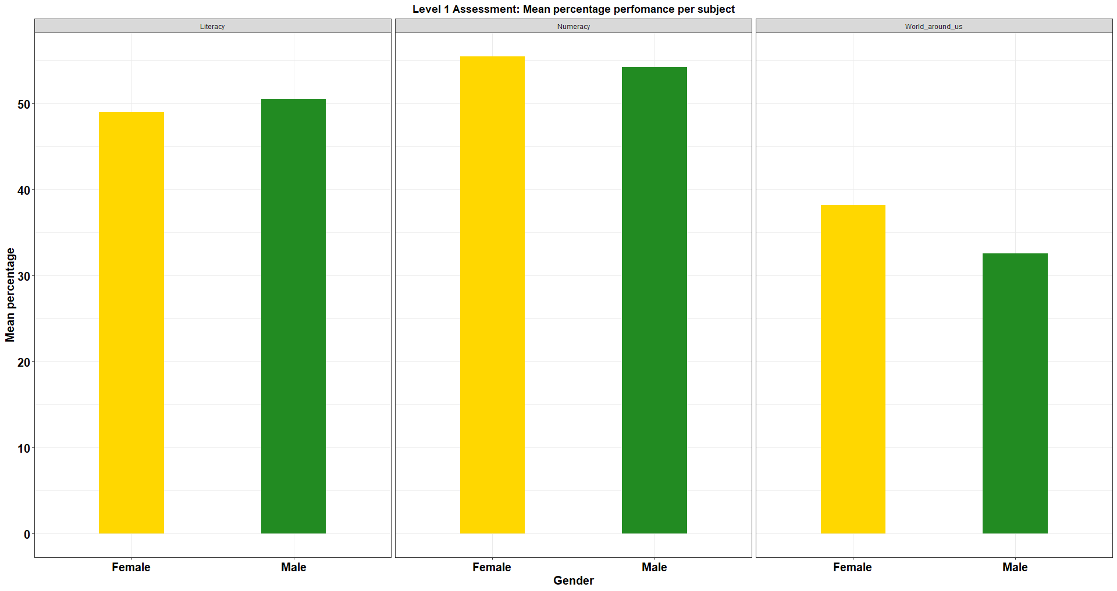

*Bar graph* *representing the general performance of the three assessment areas for Level 1 by Gender*

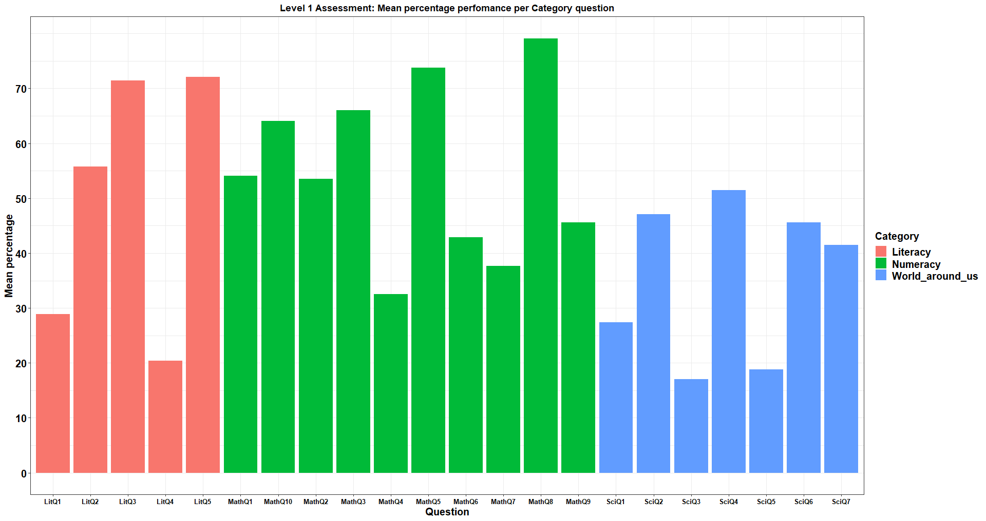

*Bar graph* *representing the general mean performance of each question in the three assessment areas for Level 1.*

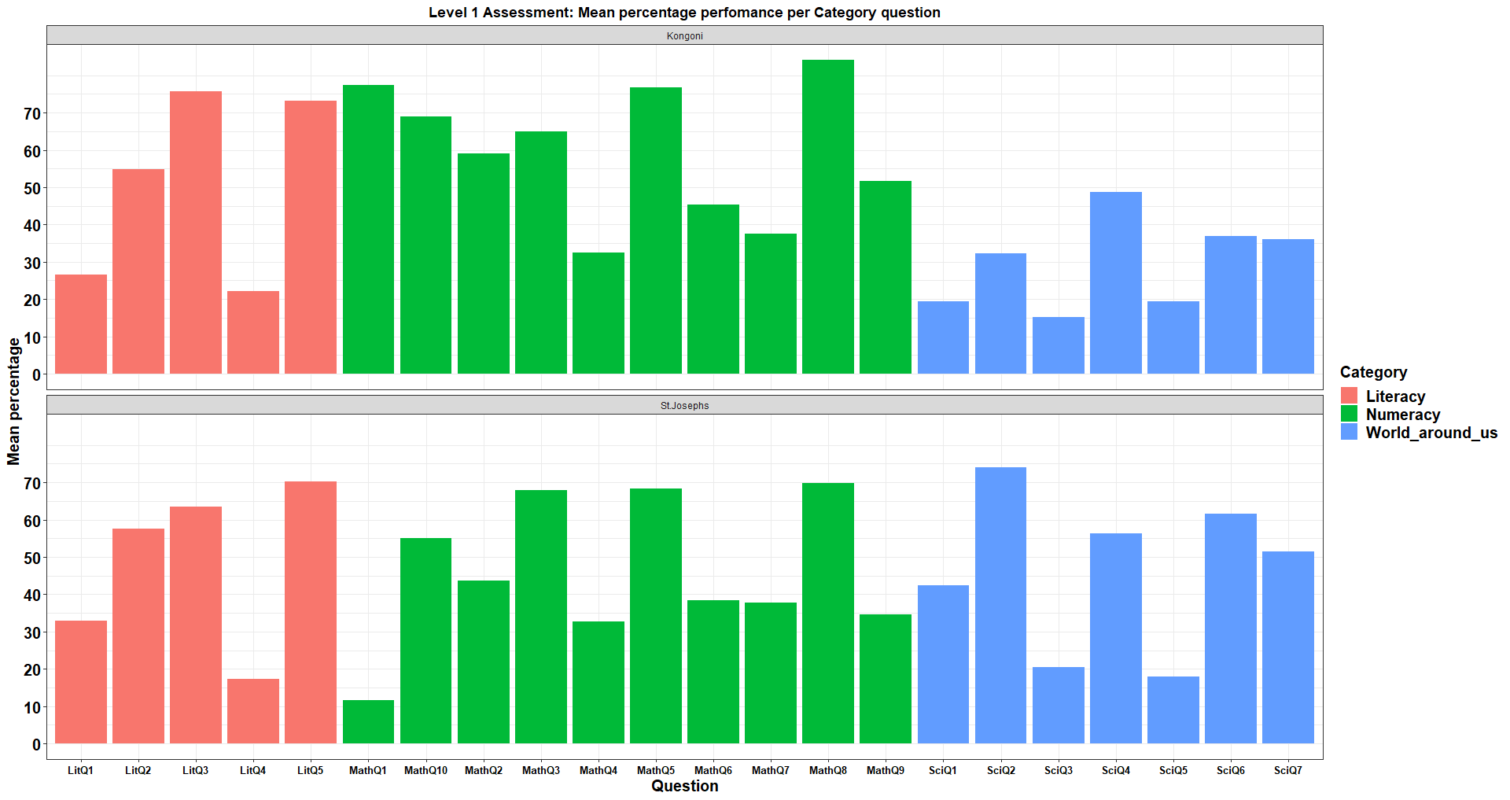

*Bar graph* *representing the general mean performance of each question in the three assessment areas for Level 1 by school.*

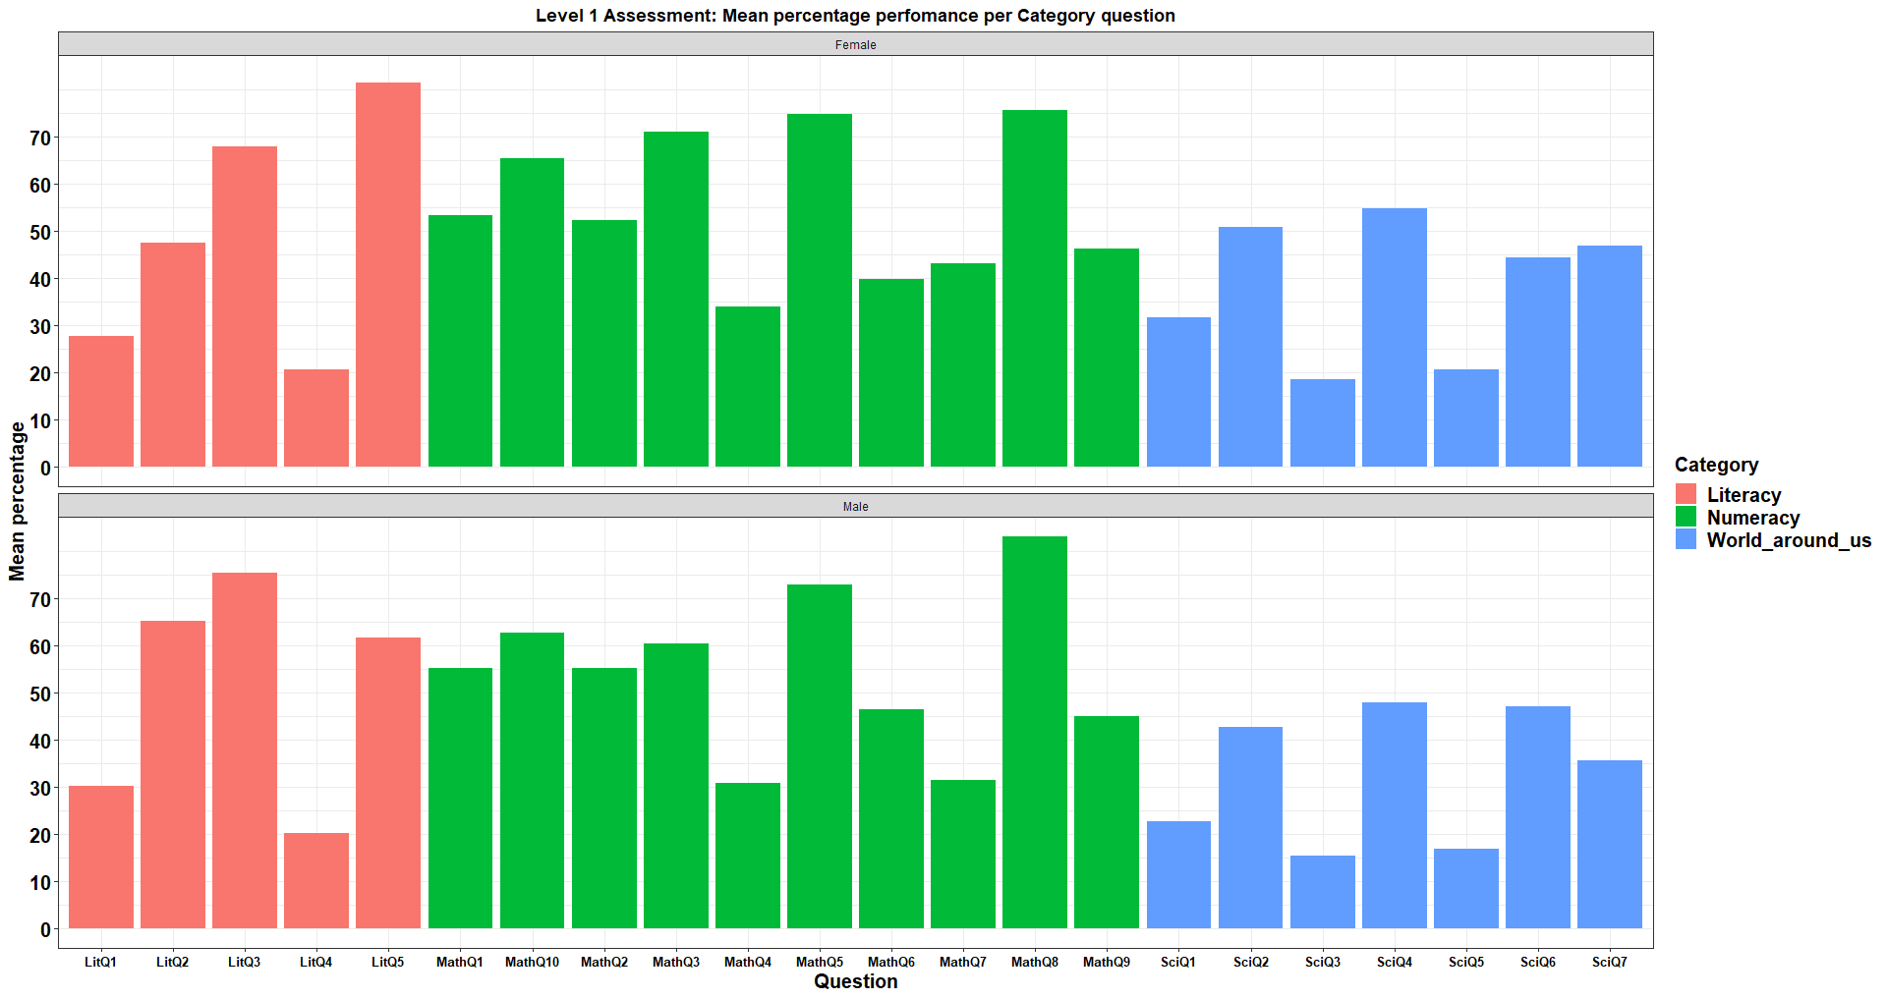

*Bar graph* *representing the general mean performance of each question in the three assessment areas for Level 1 by gender*

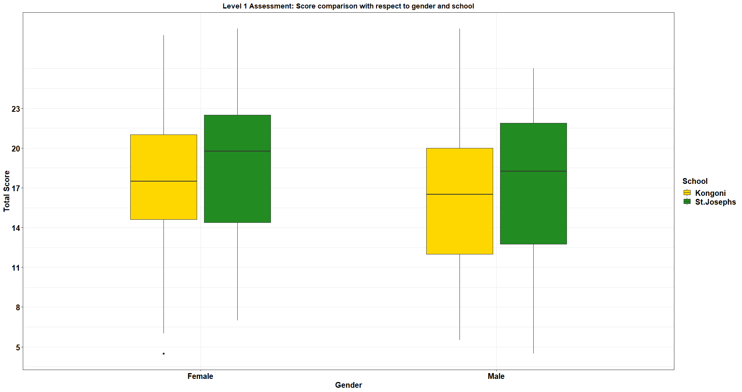

*Boxplots representing the total score performance in all the three assessment areas for Level 1 by gender and school*

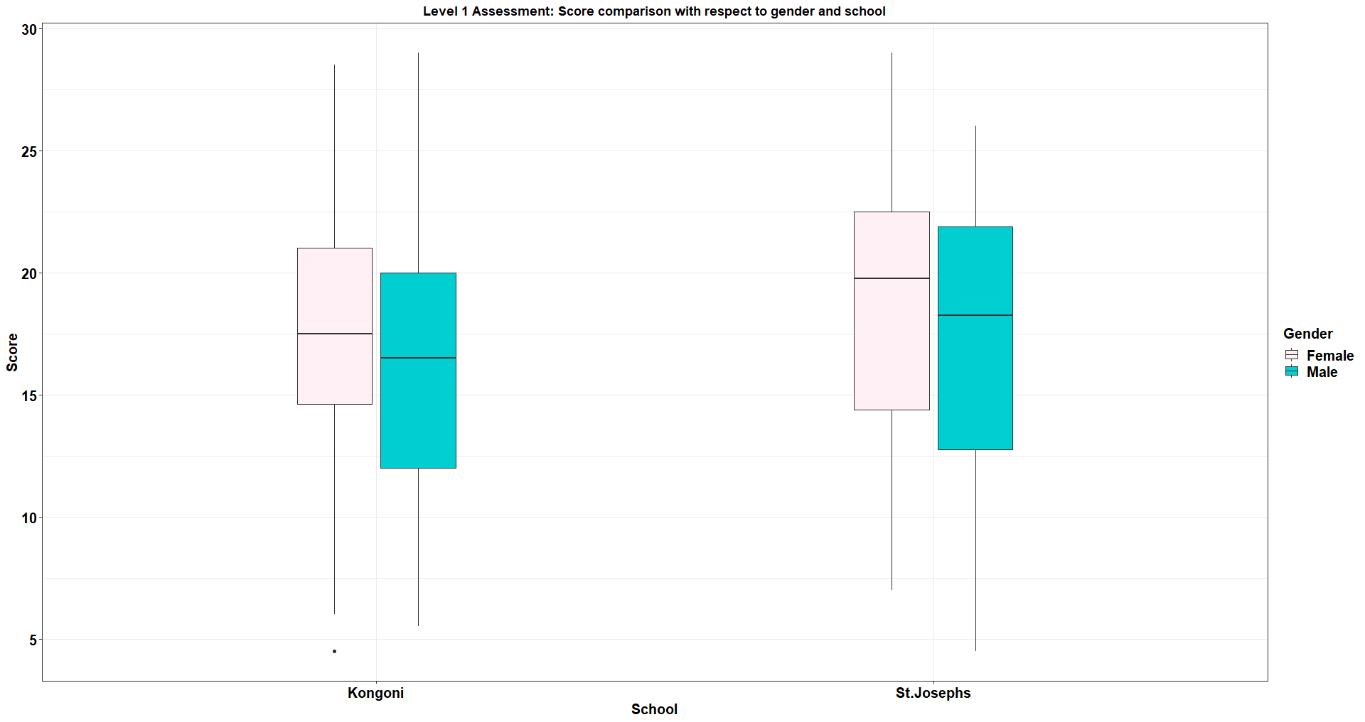

*Boxplots representing the total score performance in all the three assessment areas for Level 1 by gender and school*

***Math performance***

* There is a slight difference in math performance by gender but females have a better performance than male.
* Kongoni school doing better in math on average than St. Josephs
* MathQ8 being highly performed and MathQ4 being the least performed as shown in the table below.

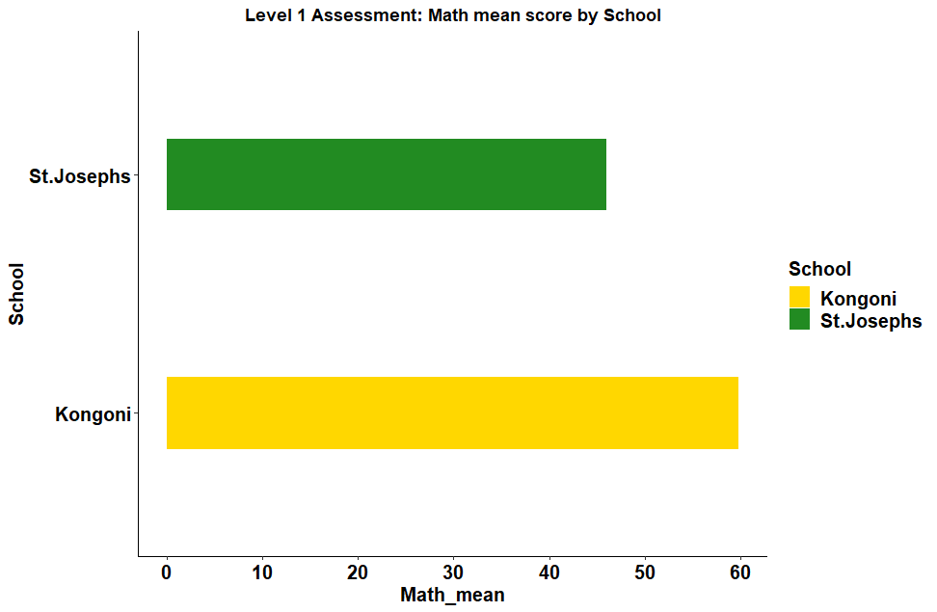

*Bar graph* *representing the numeracy performance for Level 1 by school.*

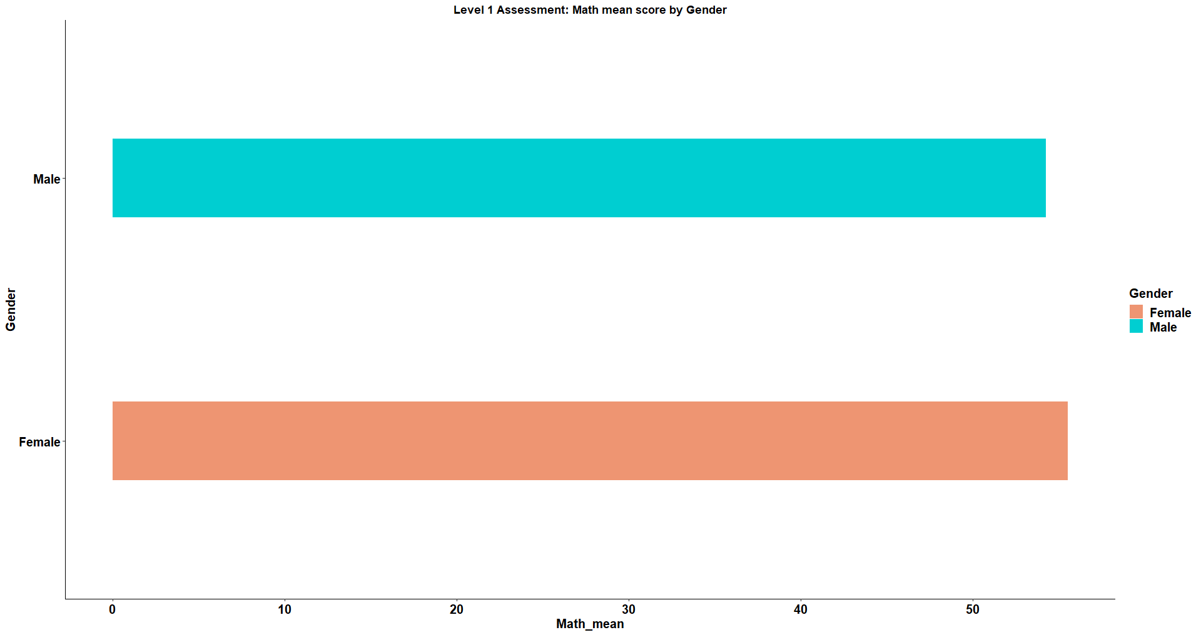

*Bar graph* *representing the numeracy performance for Level 1 by gender.*

| Question | mean_percentage |
| --- | --- |
| MathQ8 | 79.14 |
| MathQ5 | 73.81 |
| MathQ3 | 65.99 |
| MathQ10 | 64.08 |
| MathQ1 | 54.08 |
| MathQ2 | 53.52 |
| MathQ9 | 45.58 |
| MathQ6 | 42.86 |
| MathQ7 | 37.64 |
| MathQ4 | 32.48 |

*Student performance on each math question.*

***Science performance***

* Females doing better than males in science.
* St. Joseph performing highly better than Kongoni in Science.
* SciQ4 being highly performed and SciQ3 being the least performed as shown in the table below.
* Generally, the pupils performed poorly in science compared to math.

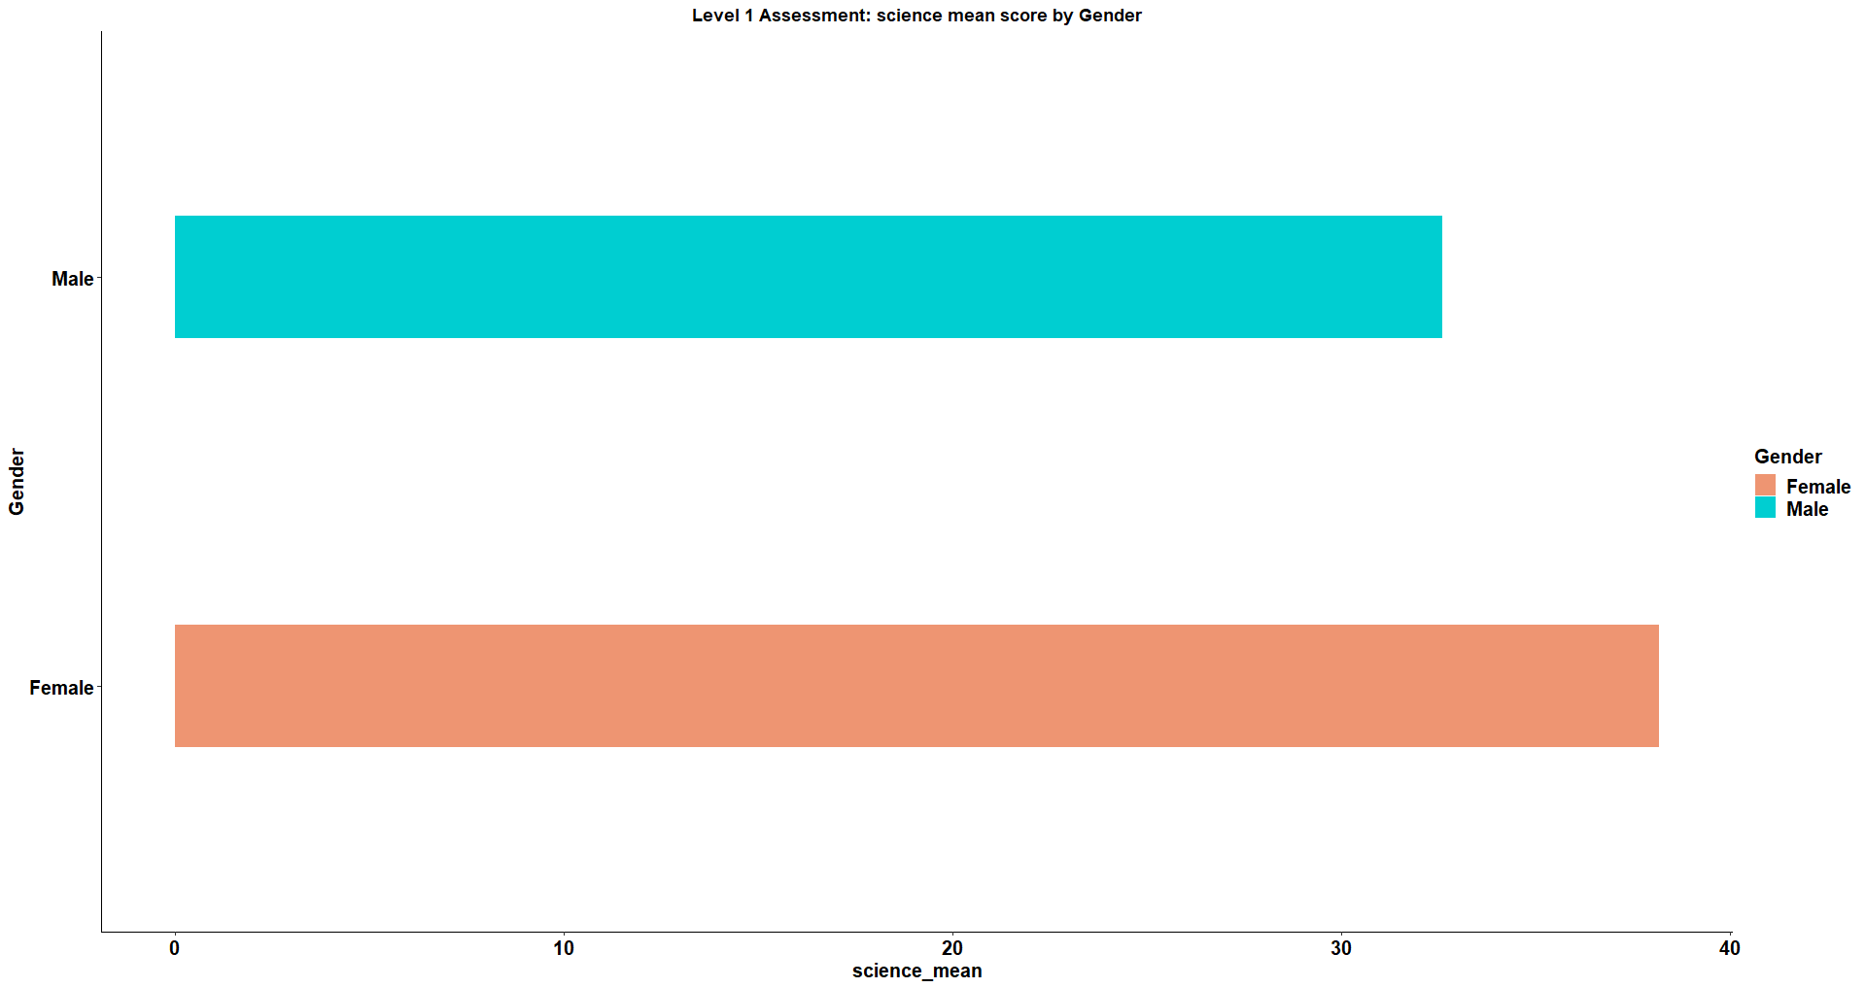

*Bar graph* *representing the world around us performance for Level 1 by gender.*

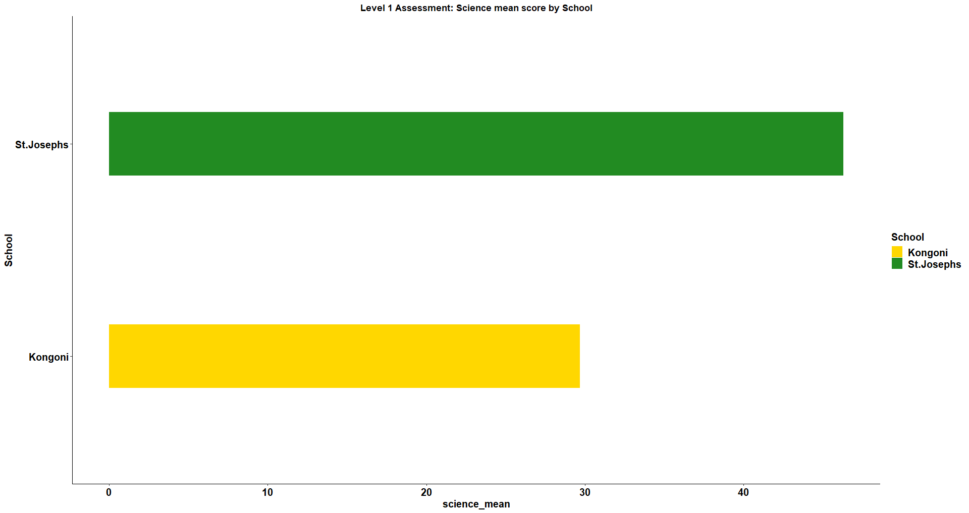

*Bar graph* *representing the world around us performance for Level 1 by school.*

| Question | mean_percentage |
| --- | --- |
| SciQ4 | 51.47 |
| SciQ2 | 47.05 |
| SciQ6 | 45.58 |
| SciQ7 | 41.50 |
| SciQ1 | 27.44 |
| SciQ5 | 18.82 |
| SciQ3 | 17.01 |

*Student performance on each Science question.*

***Literacy performance***

* There was a slight difference in math performance in both by gender and school but males performed better than the females and St. Joseph performed better than Kongoni respectively.
* LitQ5 being highly performed and LitQ4 being the least performed as shown in the table below .

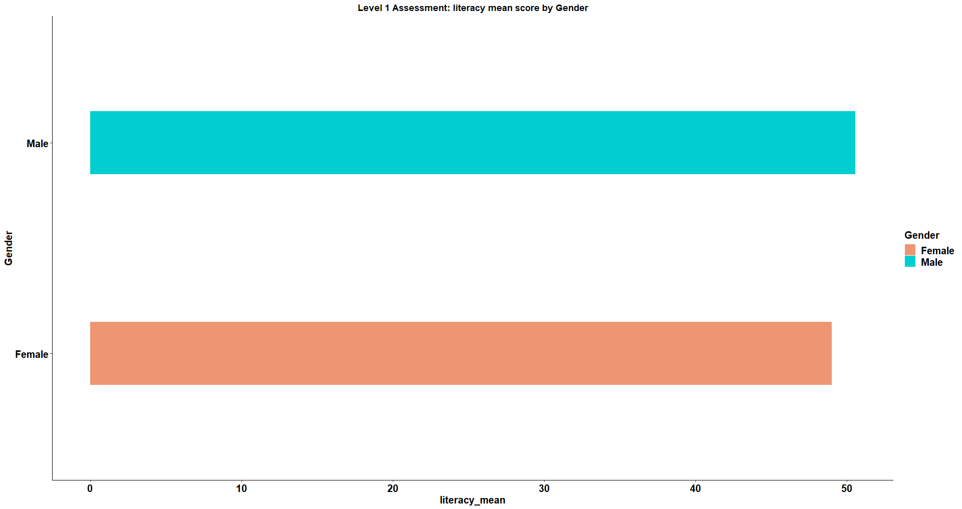

*Bar graph* *representing the literacy performance for Level 1 by gender*

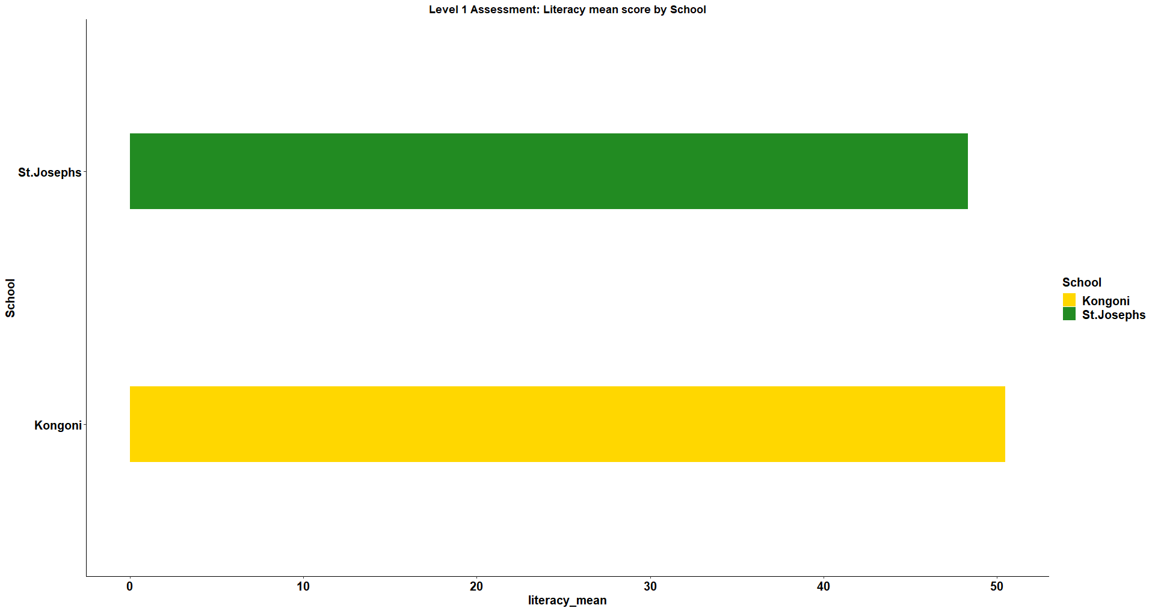

*Bar graph* *representing the literacy performance for Level 1 by school.*

| Question | mean_percentage |
| --- | --- |
| LitQ5 | 72.11 |
| LitQ3 | 71.43 |
| LitQ2 | 55.78 |
| LitQ1 | 28.86 |
| LitQ4 | 20.41 |

*Student performance on each Literacy question.*

***Skills performance***

* There was a slight difference in the mean score in males and females but the females performed better.
* St.Joseph are performing highly in skills better than Kongoni primary.

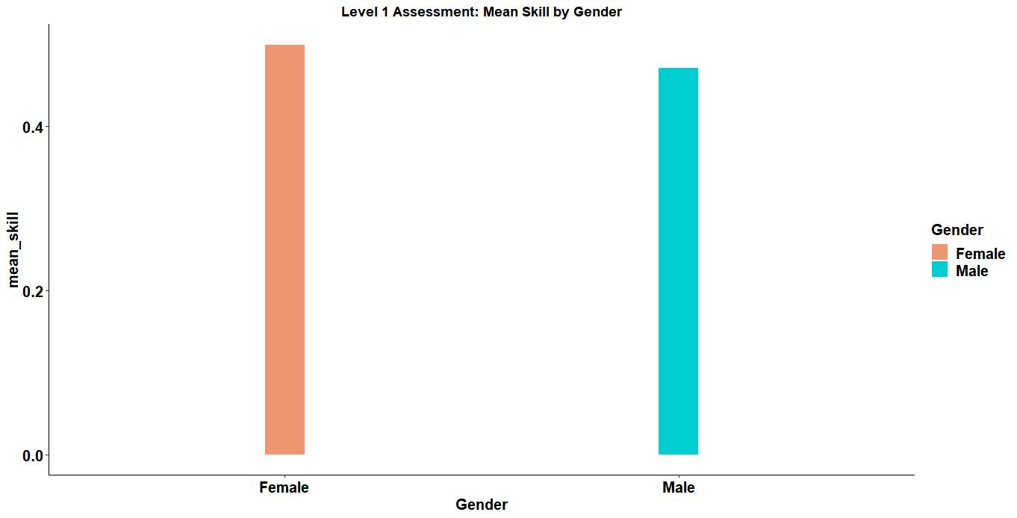

*Bar graph* *representing the 21st century skills performance for Level 1 by gender*

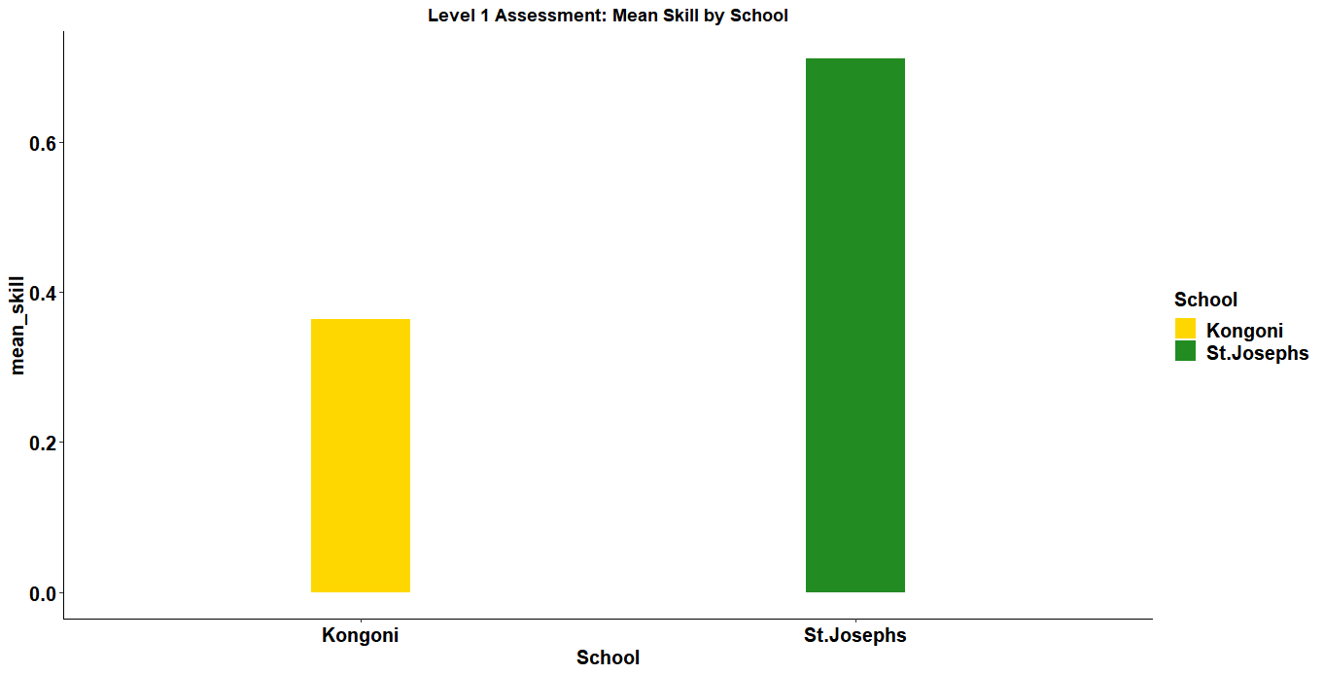

*Bar graph* *representing the 21st century skills performance for Level 1 by school.*

**Level 2 Assessment:**

* The assessment was done by two schools, St. Joseph Primary(72 pupils) and Kongoni Primary(112 pupils)
* It was done by a total of 184 pupils with 94 being females and 90 males as shown below.

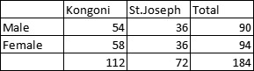

**General performance: level 2**

* In level 2, the students performed better in numeracy (44.1%) compared to the other assessment areas, World_around_us (38.8%) and Literacy (19.1%).
* When grouped by gender the females are doing better in all the subjects than their males counterparts.
* Though the general performances in all the schools are quite low St.Joseph is leading(38.4) and Kongoni(35.6)

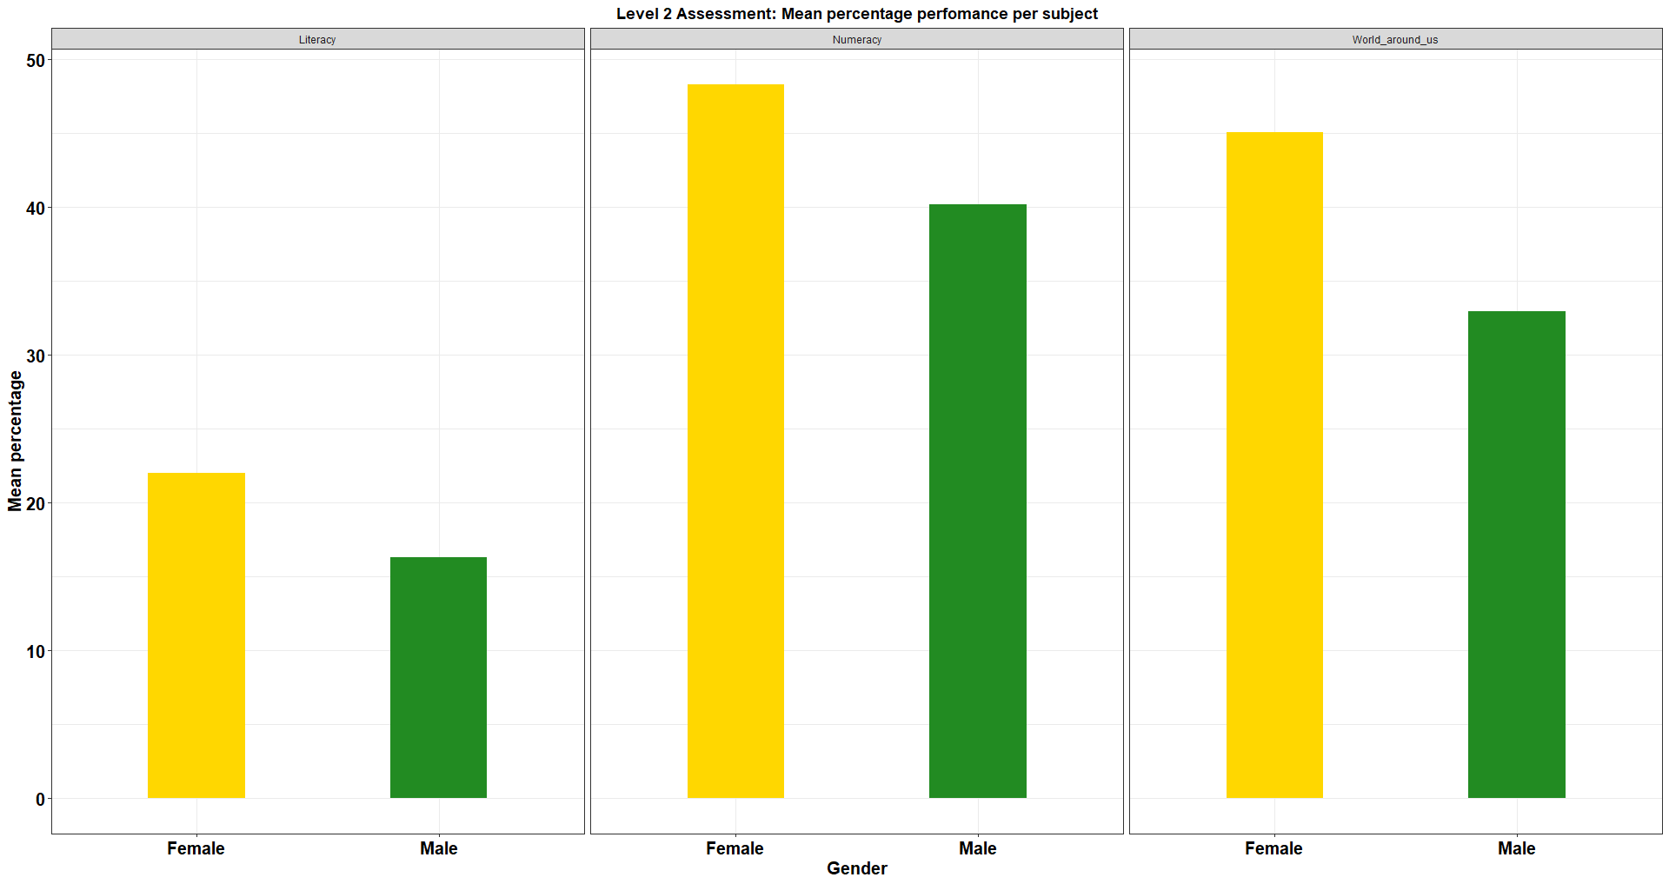

*Bar graph* *representing the general performance of the three assessment areas for Level 2 by gender*

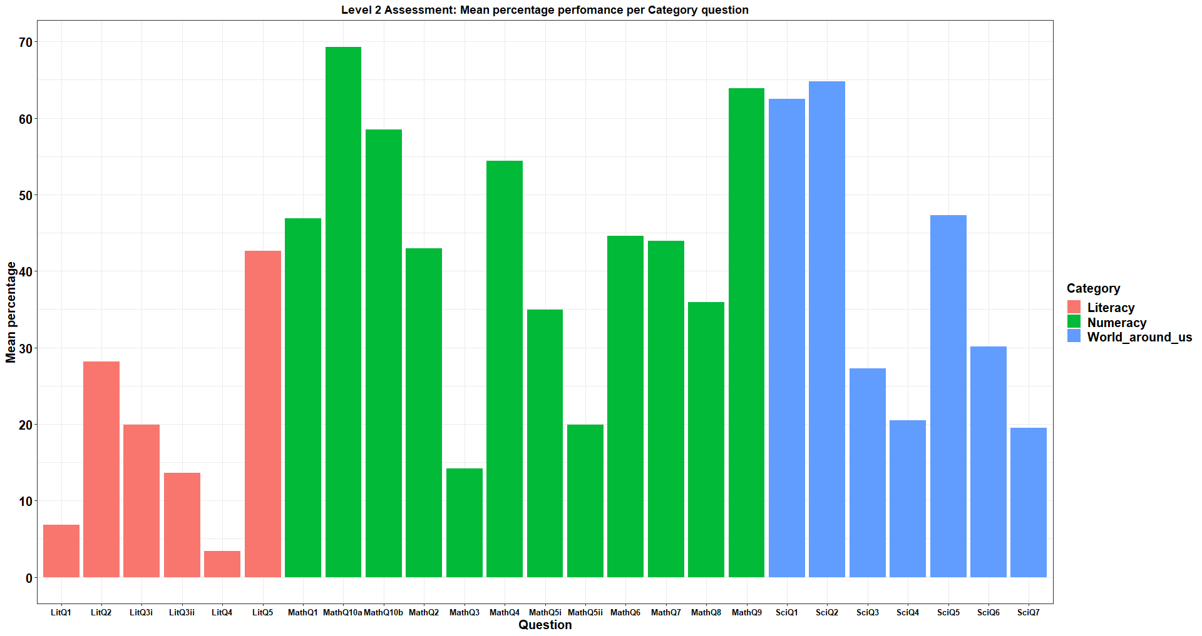

*Bar graph* *representing the general mean performance of each question in the three assessment areas for Level 2*

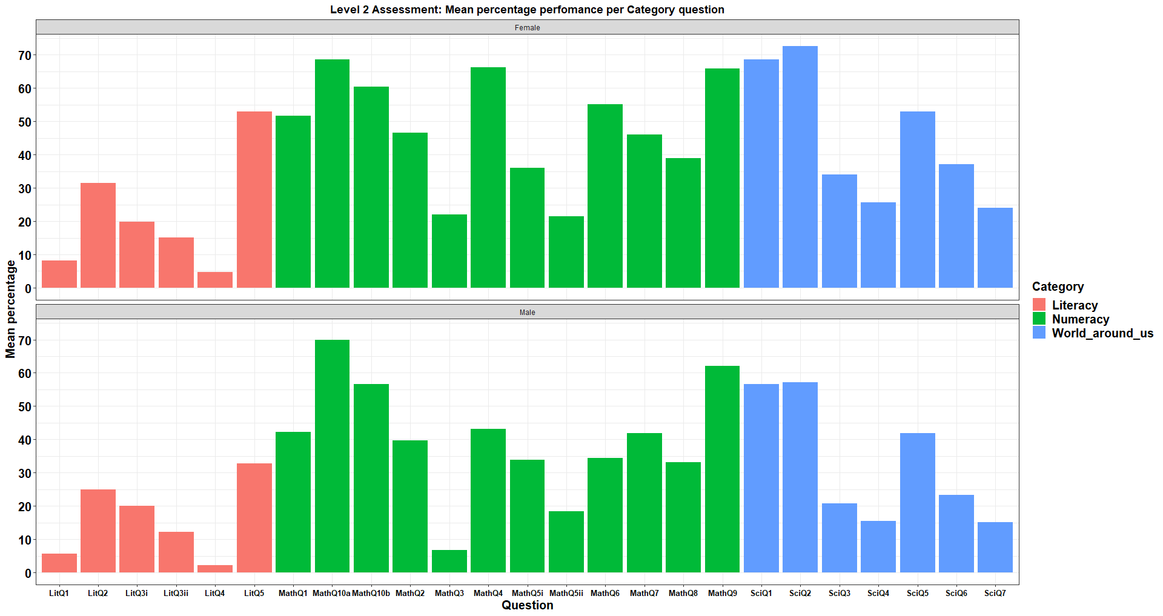

*Bar graph* *representing the general mean performance of each question in the three assessment areas for Level 2 grouped by gender*

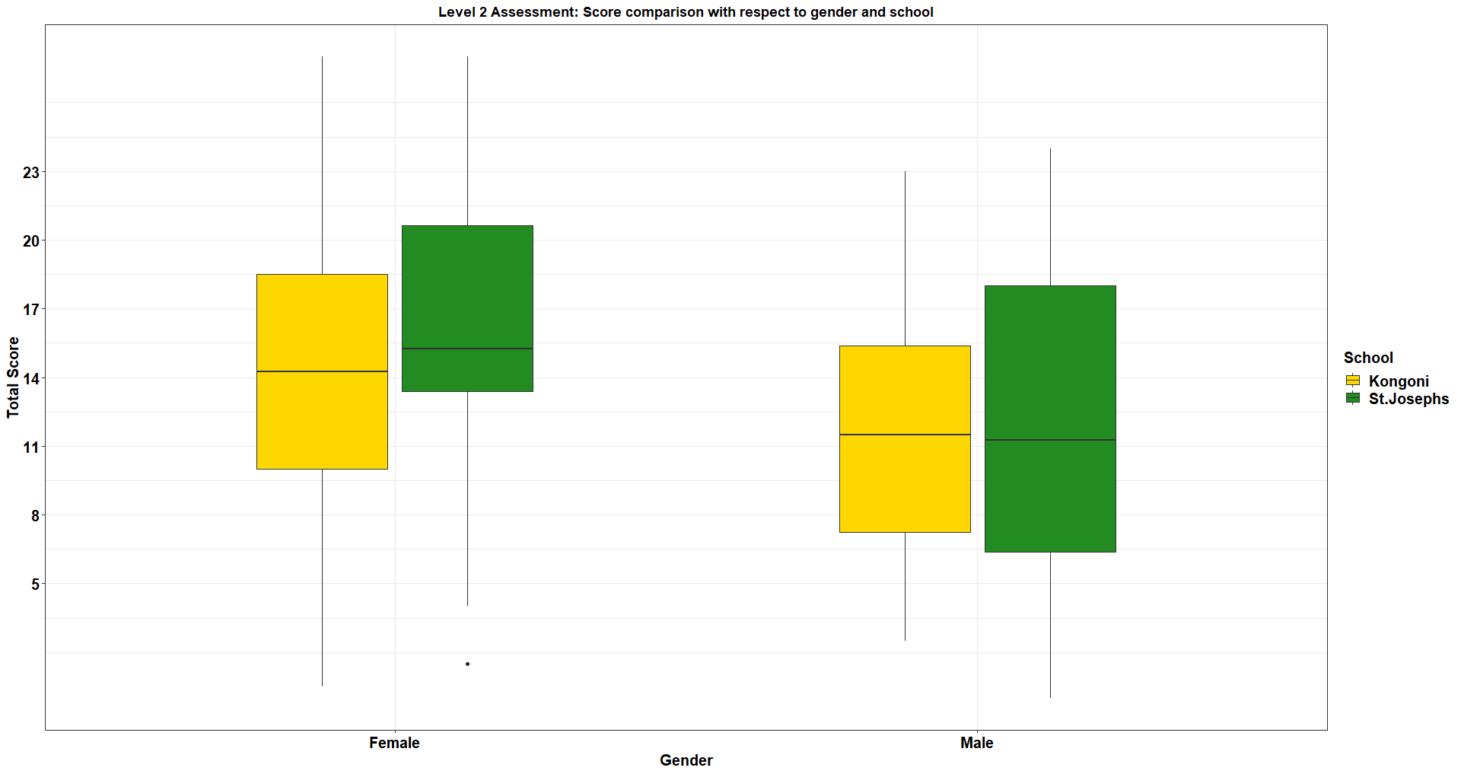

*Boxplot**representing the score comparison in the three assessment areas for Level 2 grouped by gender and school.*

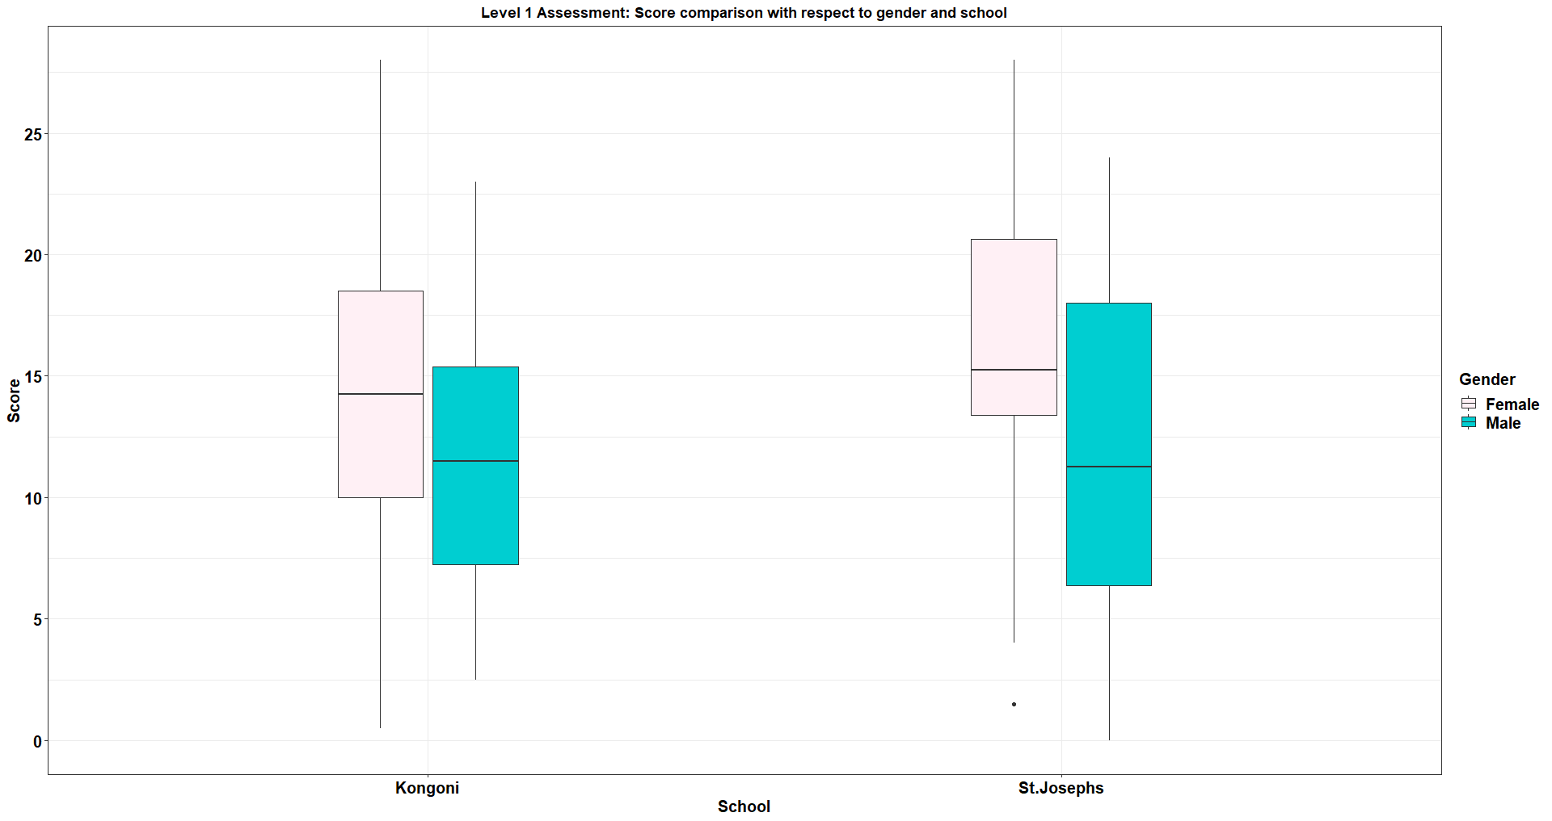

*Boxplot**representing the score comparison in the three assessment areas for Level 2 grouped by gender and school.*

***Math performance***

* *Females performed better in mathematics than males.*
* *The mean average between the two schools was the same.*
* *MathQ10a being highly performed and MathQ3 being the least performed as shown in the table below.*

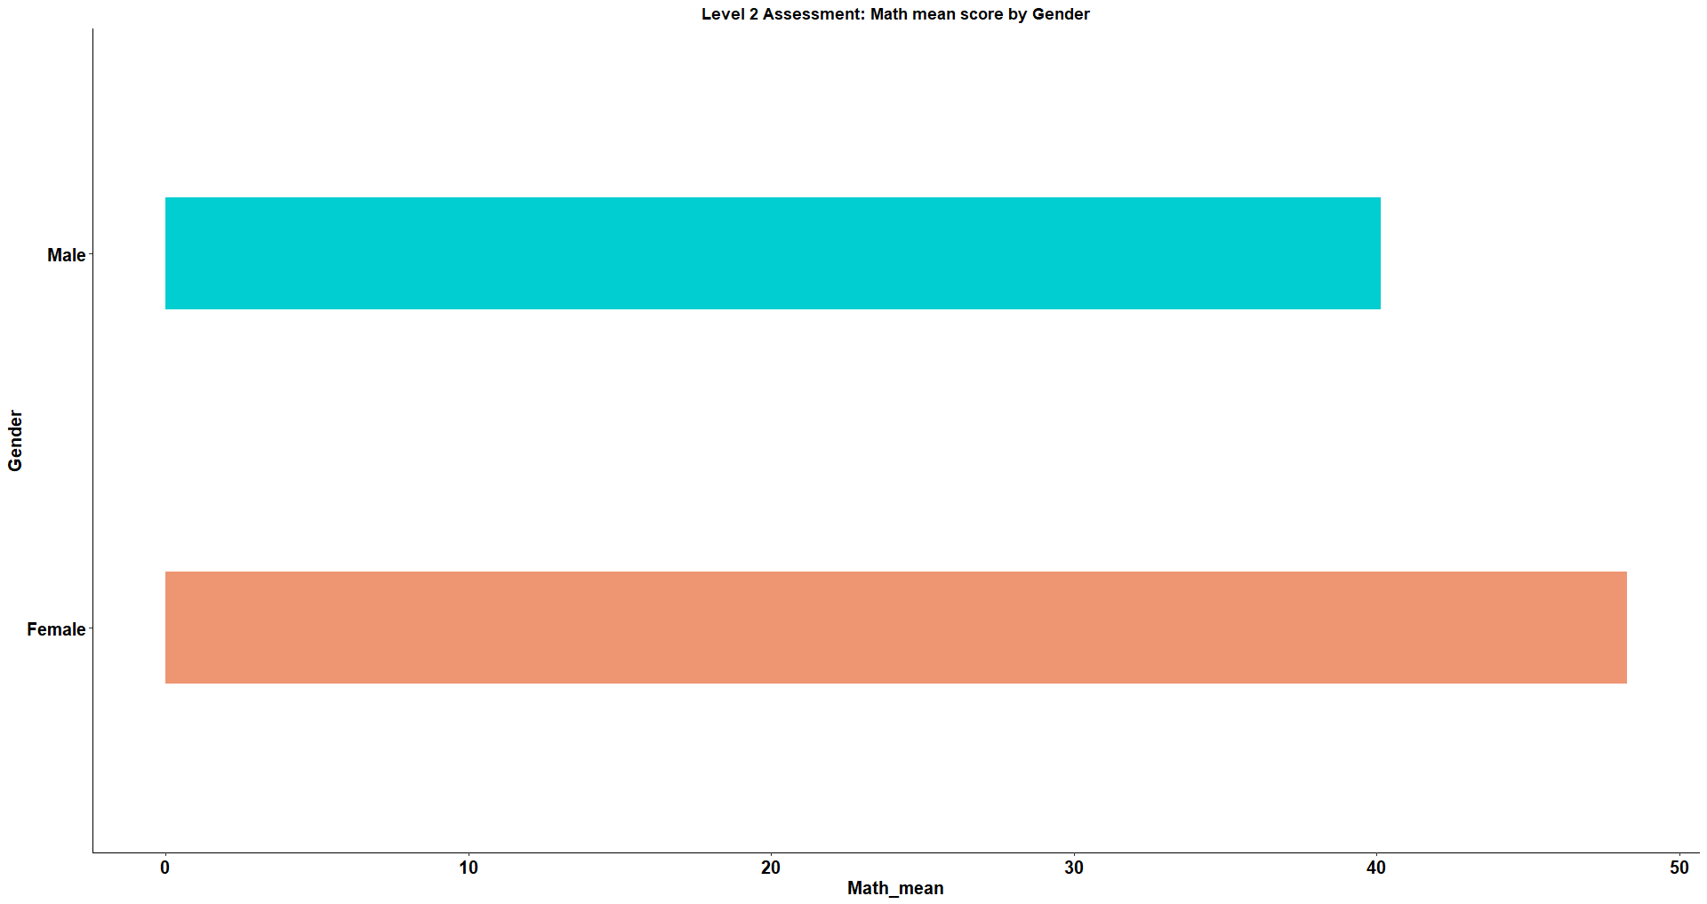*Bar graph* *representing the numeracy performance for Level 2 by gender*

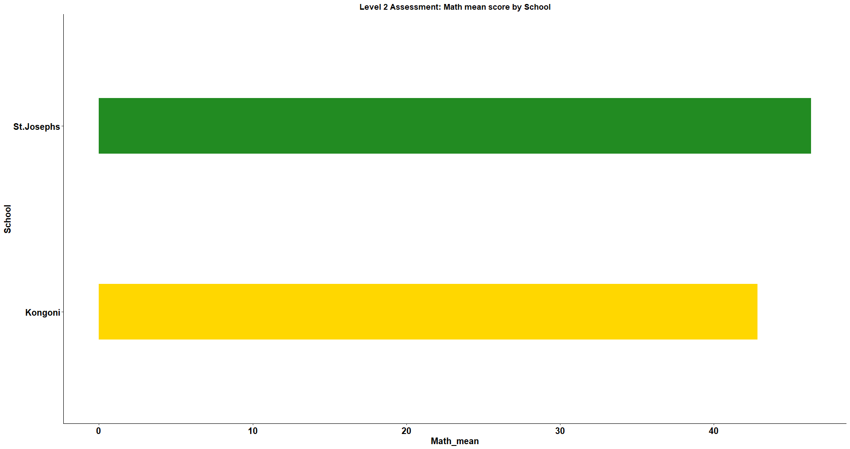

*Bar graph* *representing the numeracy performance for Level 2 by school*

| Question | mean_percentage |
| --- | --- |
| MathQ10a | 69.32 |
| MathQ9 | 63.86 |
| MathQ10b | 58.52 |
| MathQ4 | 54.43 |
| MathQ1 | 46.88 |
| MathQ6 | 44.60 |
| MathQ7 | 43.94 |
| MathQ2 | 42.99 |
| MathQ8 | 35.94 |
| MathQ5i | 34.94 |
| MathQ5ii | 19.89 |
| MathQ3 | 14.20 |

*Student performance on each mathematics question.*

***Science performance***

* Females performed highly in science than the males in science.
* St.Josephs performed had a high mean score in science better than Kongoni.
* *SciQ2 being highly performed and SciQ7 being the least performed as shown in the table below.*

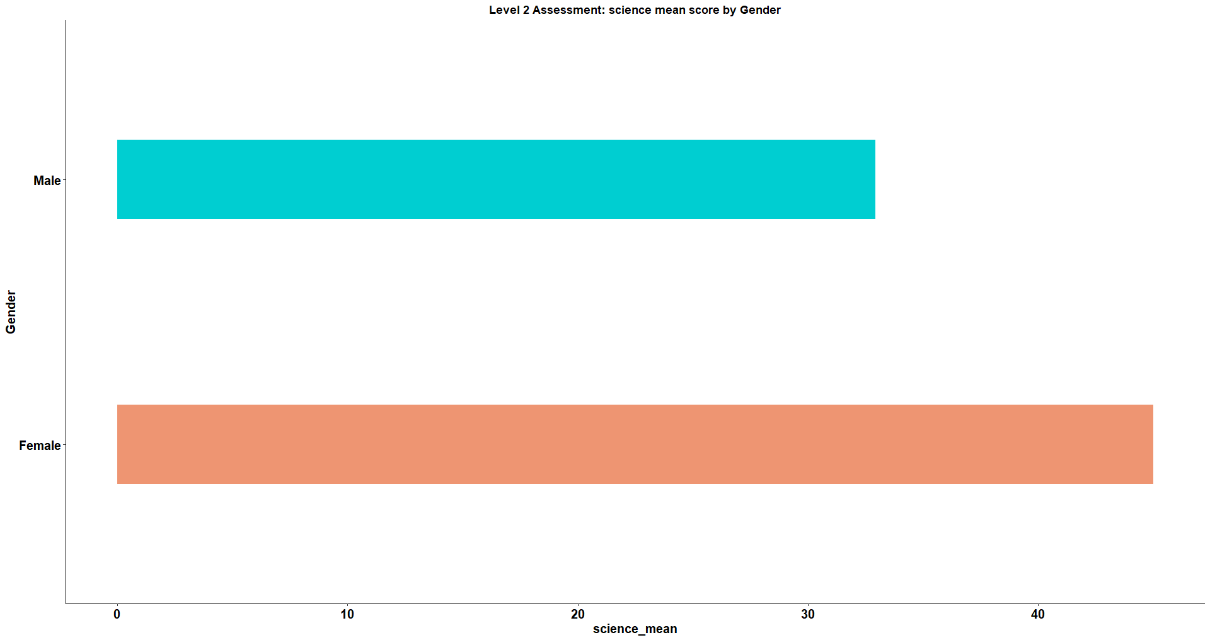

*Bar graph* *representing the world around us performance for Level 2 by gender*

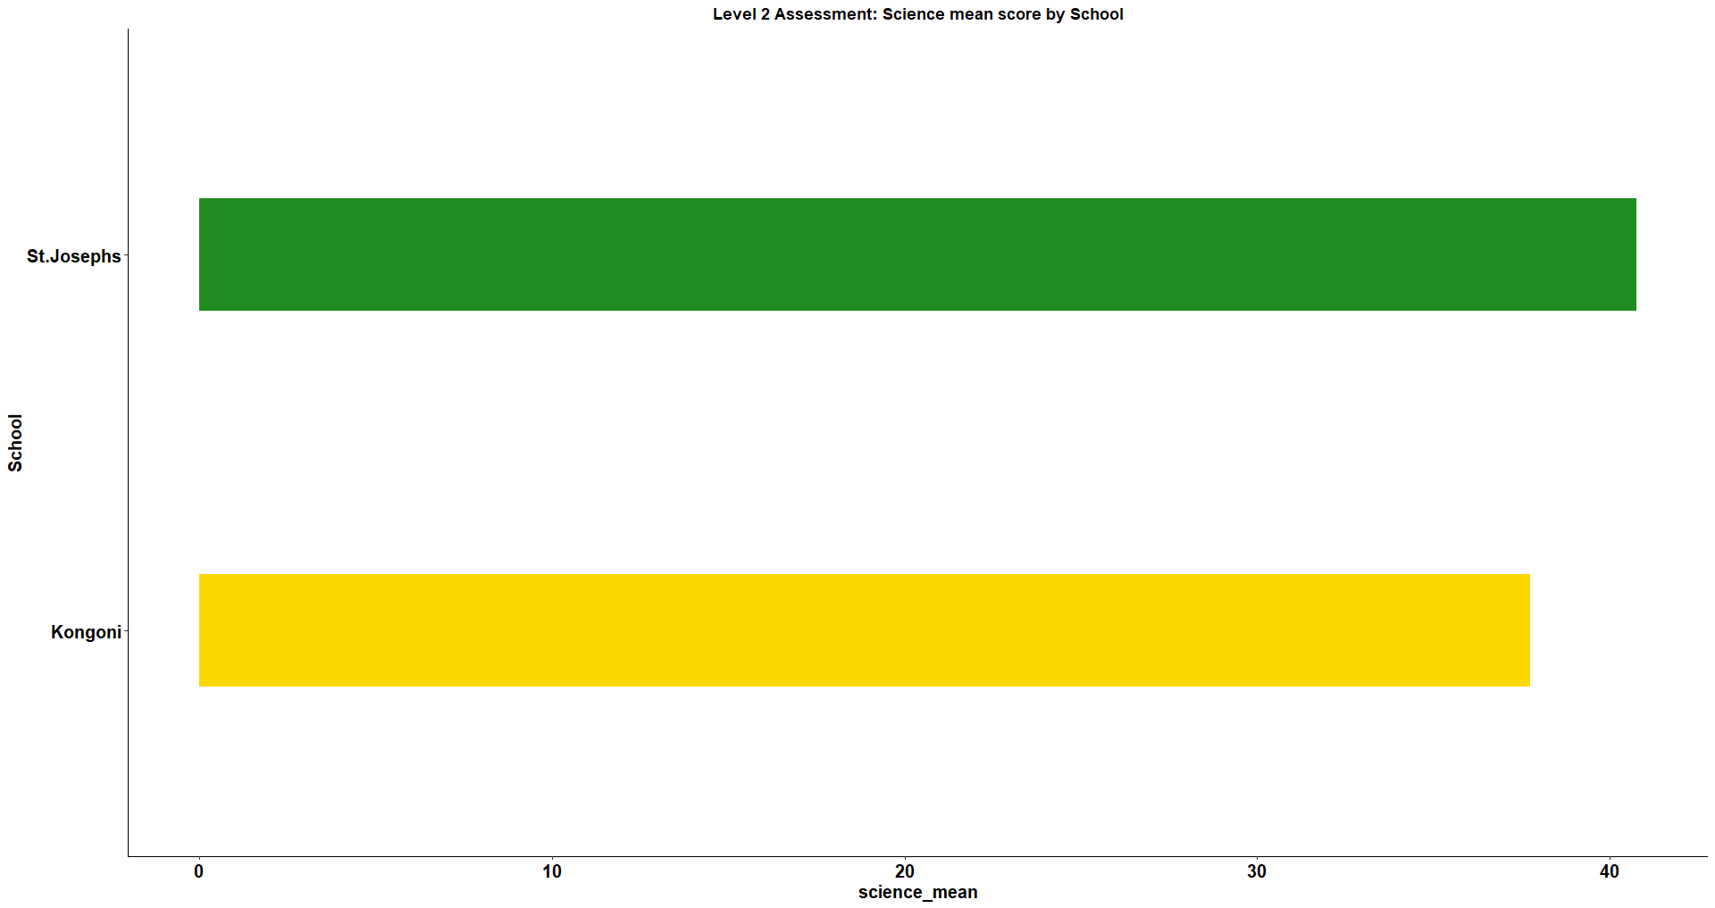

*Bar graph* *representing the numeracy performance for Level 2 by school*

| Question | mean_percentage |
| --- | --- |
| SciQ2 | 64.77 |
| SciQ1 | 62.50 |
| SciQ5 | 47.30 |
| SciQ6 | 30.11 |
| SciQ3 | 27.27 |
| SciQ4 | 20.45 |
| SciQ7 | 19.51 |

*Student performance on each Science question.*

***Literacy performance***

* Females performed higher than the males.
* There was a slight difference in the mean average in literacy performance in both schools but Kongoni performed better.
* *LitQ5 being highly performed and LitQ4 being the least performed as shown in the table below.*

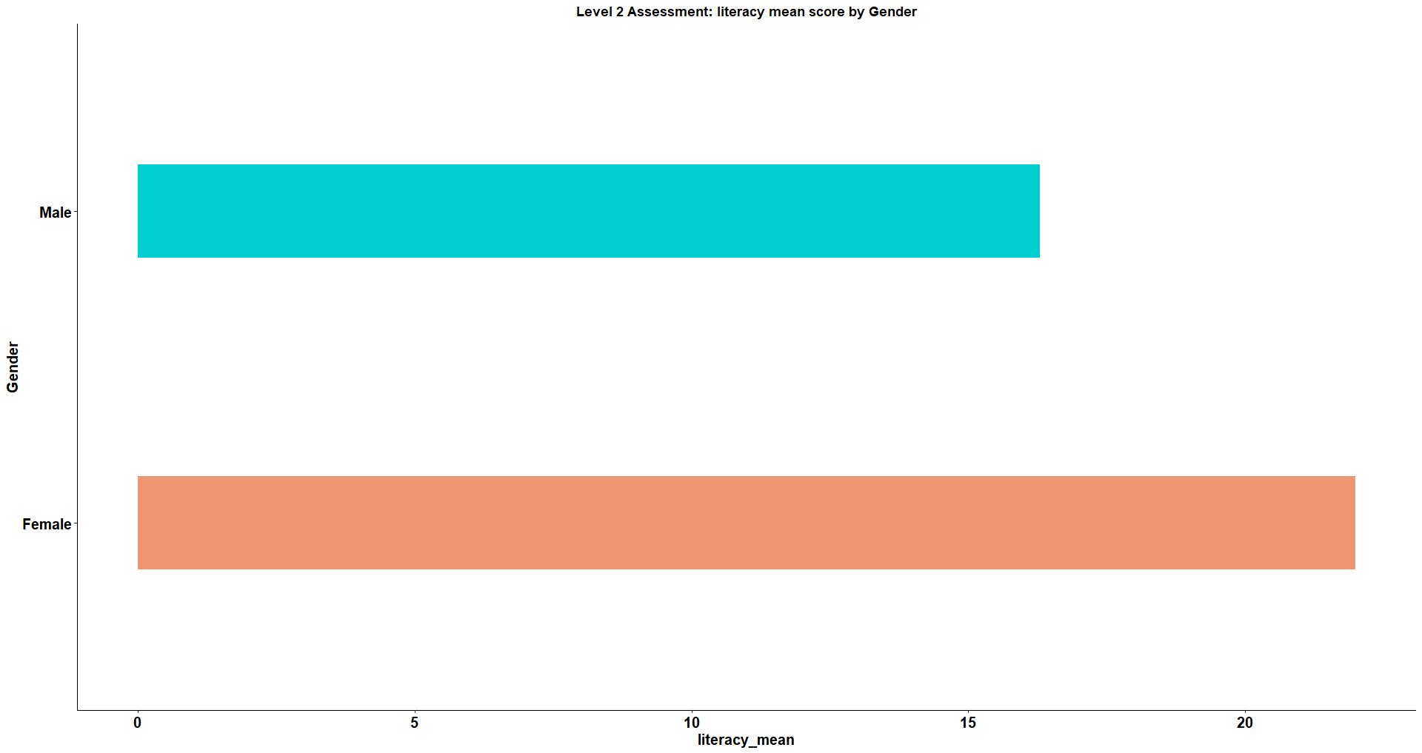

*Bar graph* *representing the literacy performance for Level 2 by gender*

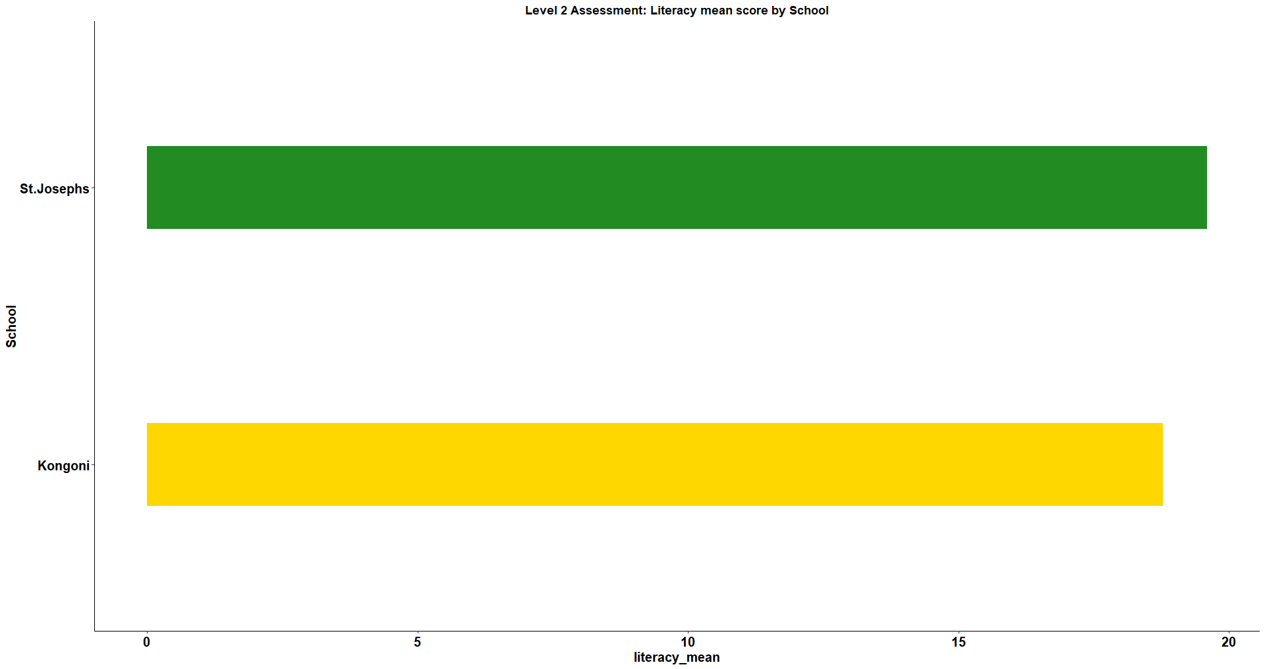

*Bar graph* *representing the numeracy performance for Level 2 by school*

| Question | mean_percentage |
| --- | --- |
| LitQ5 | 42.61 |
| LitQ2 | 28.13 |
| LitQ3i | 19.89 |
| LitQ3ii | 13.64 |
| LitQ1 | 6.82 |
| LitQ4 | 3.41 |

*Student performance on each Literacy question.*

***Skill performance***

* Females from both schools performed better in skills than their male counterparts.
* St.Josephs had a higher mean in skills performance than Kongoni.

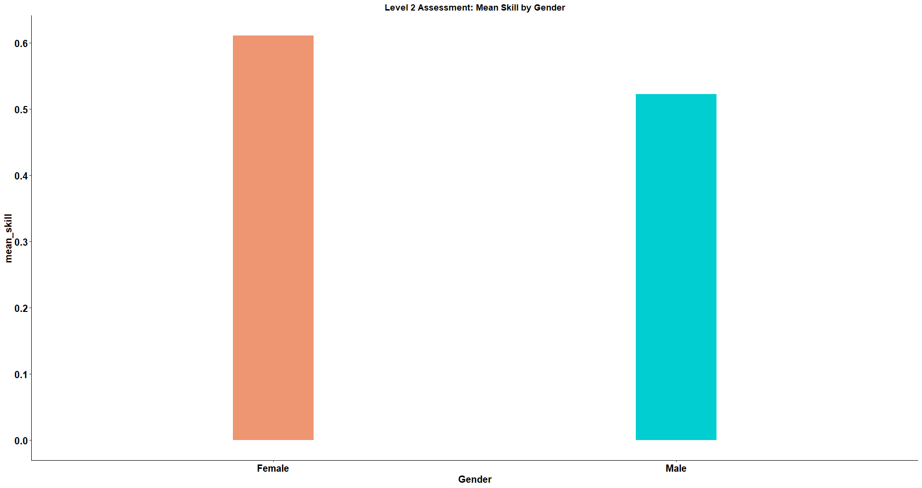

*Bar graph* *representing the 21st century skill performance for Level 2 by gender*

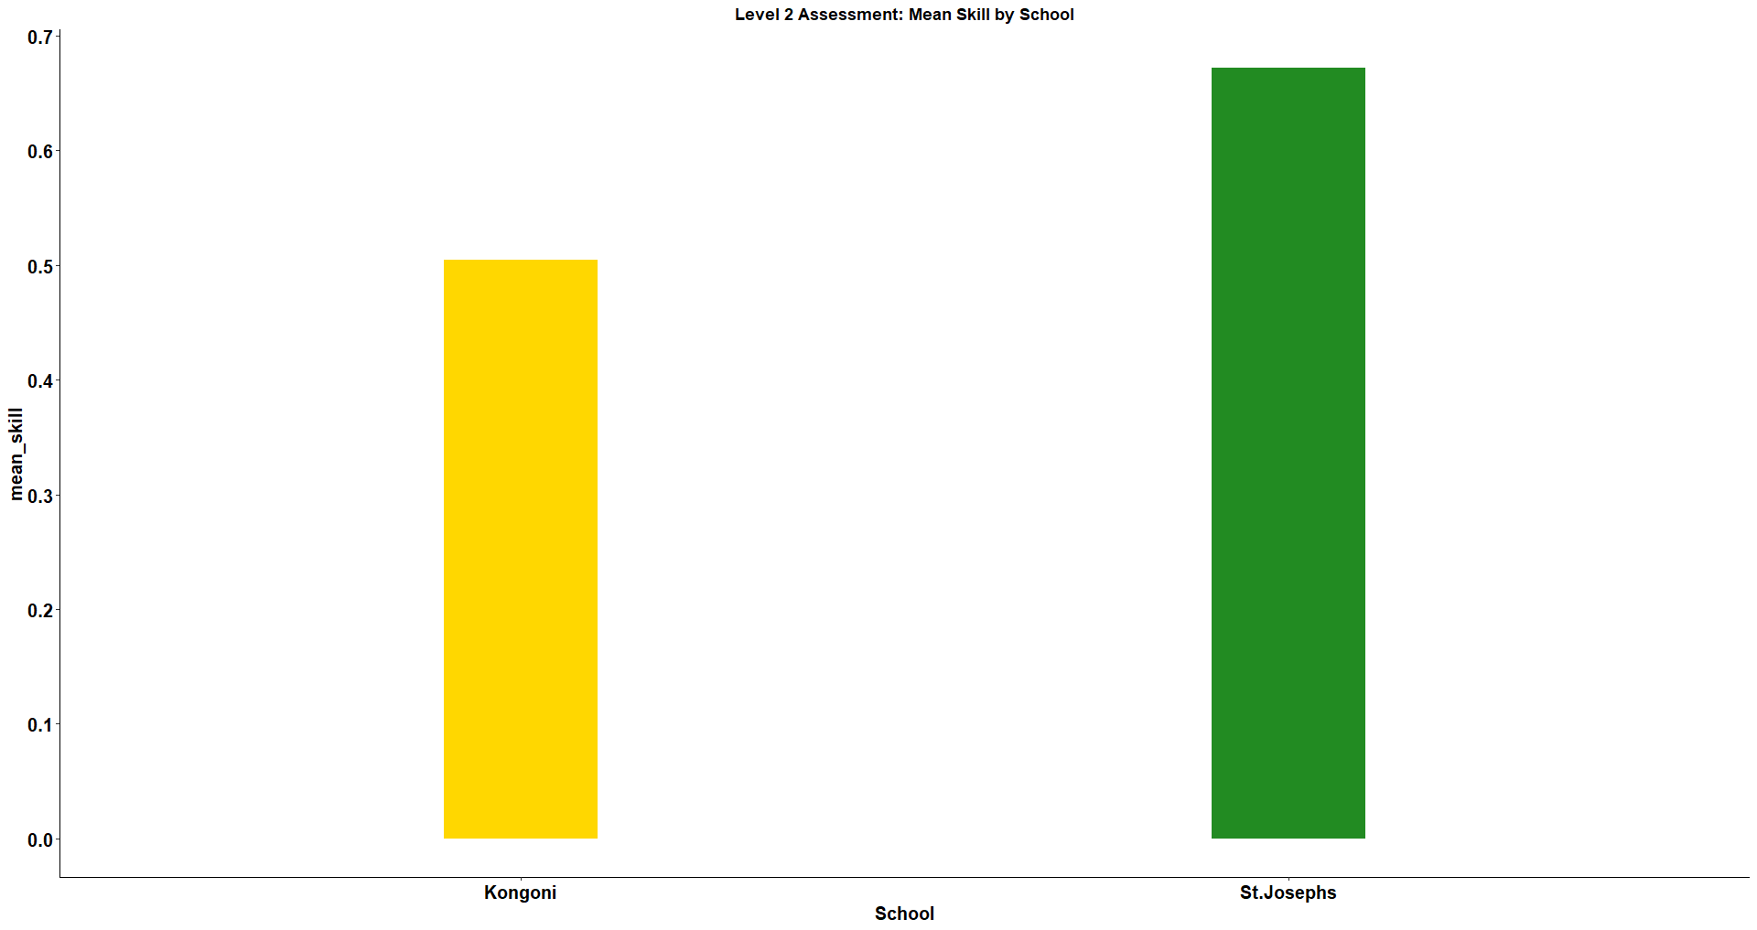

*Bar graph* *representing 21st century skill performance for Level 2 by school*